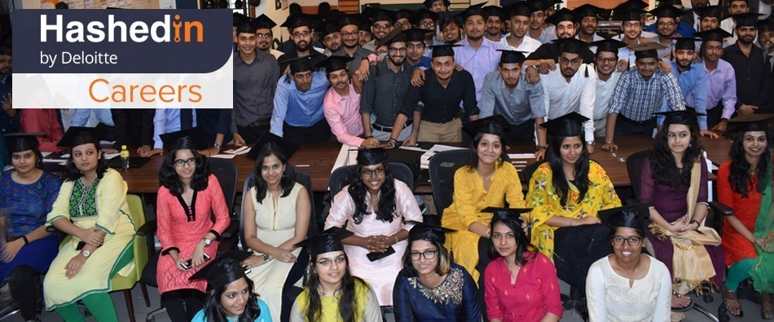

HashedIn by Deloitte Campus Recruitment – 2022

About HashedIn by Deloitte
HashedIn is a “born in the cloud” high-end product development and software engineering firm founded in 2010 by Anshuman Singh, Himanshu Varshney, Sandeep Singh, and Sripathi Krishnan. They later expanded the executive team when Harshit Singhal joined. We are specialized in cloud, web and mobility platforms. We strive to provide our clients best ROI by diagnosing problems, crafting solutions, deploying under harsh constraints, and seeing it through the finish line.

HashedIn by Deloitte is part of the Core Business Operations function within Consulting. It is a career track focused on Modern Cloud Delivery and Cloud Native Development. The HashedIn team aims at delivering products and solutions to drive Business Innovation.

Today, HashedIn engineers’ market-leading solutions leveraging cloud native technologies and modern pod-based delivery, and in the last decade, HashedIn has built, transformed, and launched over 225 products for customers across the globe.

HashedIn University
HashedIn University (HU) is an intensive, yet fun-filled unique boot camp run every year by HashedIn Technologies. It operates on the principles of "Compressed Action Learning", a formula devised by Prof. Noel Tichy. The training program is conducted with a motive of training young talented engineers and transforming them into industry-ready leaders. HashedIn University challenges the new recruits, to go through some intense sessions and in the long run help them emerge out as highly confident business professionals. It also nurtures the tendency to produce full-stack developers for digital and cloud platforms.

What if we said that HU is virtual? Sounds good right. Well, yes, HU is entirely virtual, and you can equip yourself with all necessary knowledge at the comfort of your homes. All study materials are upload in a central link that gives you unlimited access to learn. All your doubts and queries are addressed by experienced Hashers who are available throughout your training period.

Accreditations
Every accreditation is a result of the challenging work that every Hasher contributes to making HashedIn better. Their challenging work has taken HashedIn to several renowned platforms of praise.
- Great Place to Work Institute recognizes HashedIn as one of India’s Best Workplaces in IT & IT BPM 2020 for the third time in a row! HashedIn has been recognized by the Great Place to Work® Institute, again
- HashedIn Technologies Pvt Ltd has been recognized as one of India's 50 Great Mid-size Workplaces 2020 by the Great Place to Work® Institute. We tip our hat to all our Hashers who made this possible
- We are one of ‘India’s Growth Champions 2021’
- HashedIn Technologies has made it to the Deloitte 2019 Technology Fast 500 Asia Pacific rankings of the 500 fastest growing technology companies in Asia Pacific
- HashedIn featured in the “10 Emerging Analytics Startups in India 2020”
- HashedIn, recognized as "The 10 Most Scalable Cloud Solution Providers of 2019"

- HashedIn is ISO certified with the following standards:
  - ISO/IEC 27001:2013 - Information Security Management System
  - ISO 9001:2015 - Quality Management System
  - ISO/IEC 27018:2014 - Code of Practice for Protection of Personally Identifiable Information (PII)

Culture
HashedIn by Deloitte has an open culture environment with a grandeur vision. HashedIn is an employee and customer centric organization. We aim to provide a platform for Learning and Development to team members. Besides learning, the senior members are passionate about providing mentorship to inculcate entrepreneurial spirit. HashedIn provides its members freedom to experiment & immense flexibility, be it working hours, type of work, place, etc. Self-driven approach and a fast-paced environment is a cornerstone of our work culture.
HashedIn: https://youtu.be/TiftgvCdCfg
Life@HashedIn: https://www.youtube.com/watch?v=jtkEL_yPYKk&t=5s

Job Description

HashedIn is looking for young problem solvers and analytical thinkers who have a passion to learn and face new challenges every day.
Designation: Integration Engineer I
Qualification: B.E/ B.Tech/ M.E/ M.Tech (CSE and aligned branches,ECE,EEE) with no active backlogs with 80% or 8.0 CGPA throughout the academics.

Location: HSR Layout, Bangalore

Must Have Skills
- Excellent verbal and written communication skills.
- Exposure to of working in REST APIs or SOAP Web services.
- Strong command over Java.
- Basic SQL Query.
- Understanding of any Middleware tools like MuleSoft, Dell Boomi, Jitterbit, SAP PI/PO and scripting languages like Oracle PL/ SQL would be an added advantage.
- Responsible for creating scalable, maintainable, and distributed code.
- Responsible for designing, developing the code and maintaining functional, integration and end-to-end tests using Java and/or Python.
- Responsible for thinking strategically to improve code quality and help define best practices while providing high quality and scalable solutions.
- Responsible for creating microservices effectively by using Postman / Swagger / Soap UI.
- Responsible for diagnosing complex production issues, debugging and RCA.
Good to Have Skills:
- Ability to estimate efforts, identify risks, and meets project schedules.
- Ability to work with internal teams to coordinate project interlocks and deployments.
- Ability to share and communicate ideas effectively to technical and product teams.
- Ability to maintain CI/CD pipeline and final software delivery in production environments.
- Working experience of iterative/agile development methodologies.

Compensation
    - Stipend during the internship (6-months): INR 25,000 per month
    - CTC Post Conversion: 7,84,500 LPA

Campus Selection Process:
    - PPT Presentation
    - Online Test
    - Technical Interview- 1/ 2 (Based in the interview performance)
    - HR (Human Resources) Interview
    - Offer Confirmation

