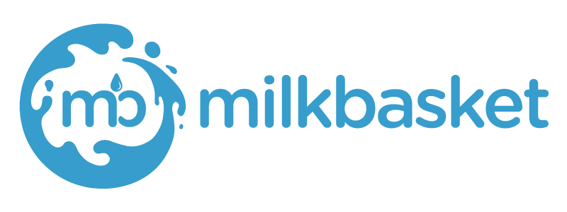
About Milk-Basket
Launched in early 2015 (https://www.milkbasket.com/), Milkbasket is India’s first and largest daily micro-delivery service which is acquired by “Reliance”. Built on the unique Indian habit of getting fresh milk delivered at home every morning, Milkbasket (accessible on milkbasket.com, iOS and Android) is today fulfilling the entire grocery needs of a household every day before 7:00 a.m. To enable frequent and friction- less buying, Milkbasket has innovated flexi ordering and contactless delivery - both a first in the ecommerce industry - and favourites of Milkbasket customers.

JD Frontend (Angular) Fresher

Responsibilities
- Delivering a complete front-end application.
- Writing tested, idiomatic, and documented JavaScript, HTML, and CSS.
- Cooperating with the back-end developer in the process of building the Web API.
- Communicating with external web services.
- Ability to optimize existing code and improve performance.
- JavaScript programming with single-page apps and/or server-side JavaScript.
- Self-motivated work style with the ability to work on several smaller projects concurrently.
- Experience working in an Agile/Scrum environment.
- Having exposure/learning attitude with JavaScript, React, Angular, jQuery, Bootstrap, and HTML5.
- Extensive knowledge of CSS and JS methods for providing performance.

