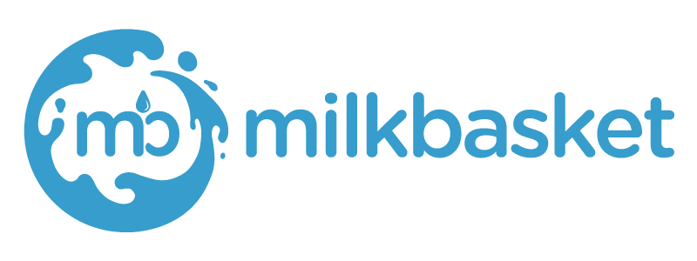
About Milk-Basket
Launched in early 2015 (https://www.milkbasket.com/), Milkbasket is India’s first and largest daily micro-delivery service which is acquired by “Reliance”. Built on the unique Indian habit of getting fresh milk delivered at home every morning, Milkbasket (accessible on milkbasket.com, iOS and Android) is today fulfilling the entire grocery needs of a household every day before 7:00 a.m. To enable frequent and friction- less buying, Milkbasket has innovated flexi ordering and contactless delivery - both a first in the ecommerce industry - and favourites of Milkbasket customers.

JD Java (Fresher)

Responsibilities
Looking for a Java/J2EE Developer with excellent programming skills. The candidate will have to develop web based applications based on the business requirements. The candidate should be able to implement web-based interfaces. The candidate will work on a development environment. We are looking for fresh Talent with learning attitude along with Excellent written and verbal communication. The candidate well known with the following technologies
Core Java
Java/ J2EE
Spring Framework
Spring Boot
Spring Security
RestFull API
Hibernate
Kafka Server (Added advantage)
Ajax
SQL(MySql)
Role: Software Developer
Functional Area: IT Software - Application Programming, Maintenance
Employment Type: Full Time, Permanent
Role Category: Programming & Design
Education: UG : B.Tech /B.E - Computers, MCA

