I. Process to generating CT/DT Reference ID.

Click on the below TCS NQT registration link & go to “Register Today” https://www.tcs.com/careers/TCSFresherHiringYoP2023

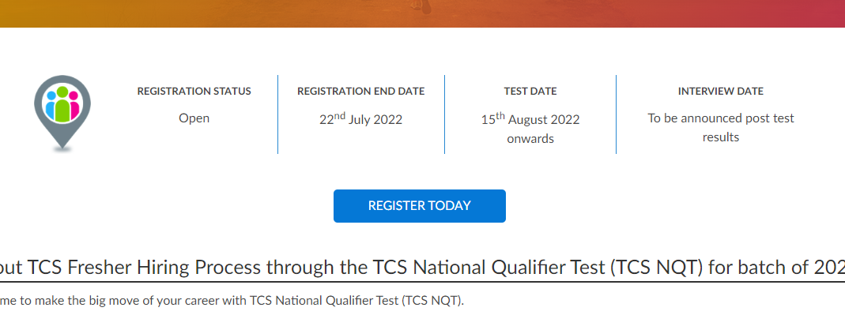

Scenario A. If you are a registered user, kindly log in and proceed to complete the application form.

Scenario B. If you are a new user, kindly click on Register Now,
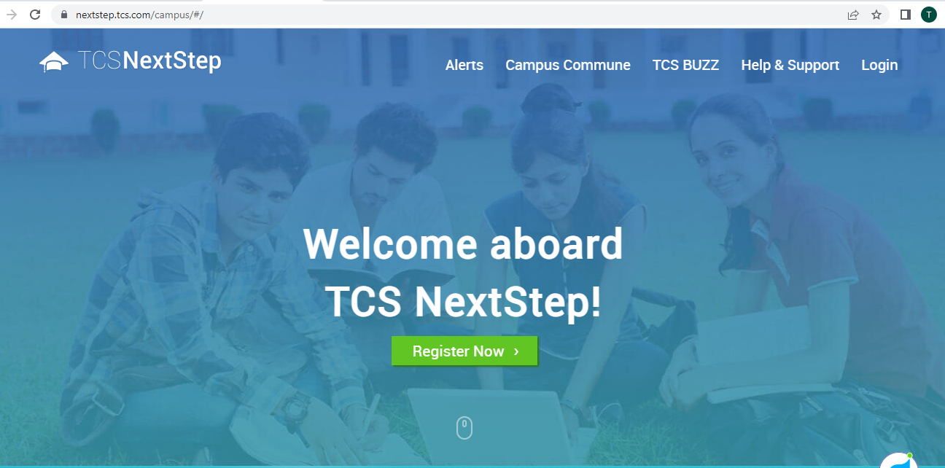

2. Choose the category “IT” and proceed to fill in your details.

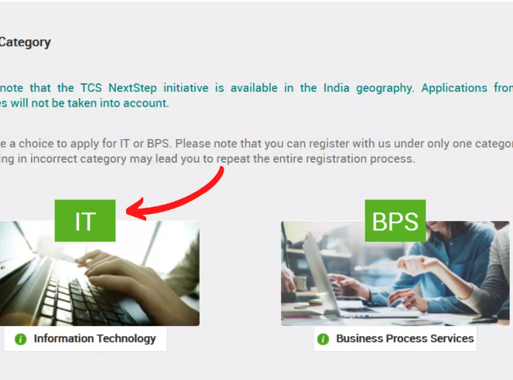

3. Fill the Application Form Details Correctly and then Submit

IMP TO NOTE: 1. Enter your email id & mobile no. correctly, you will not be able to alter it later. 2. Enter your password as per the TCS policy. 3. Remember the security question that you select

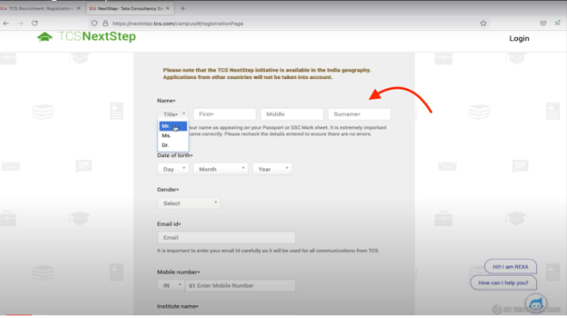
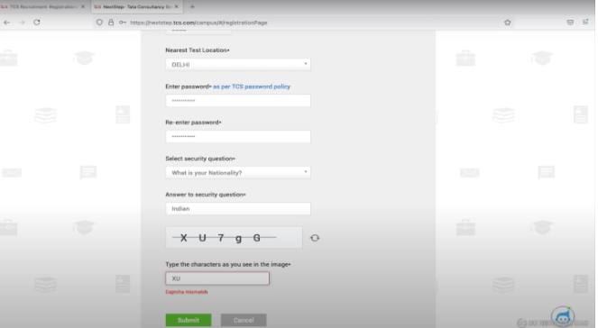

4. Confirm your email id & registered mobile no. by clicking on Confirm button of the pop-up
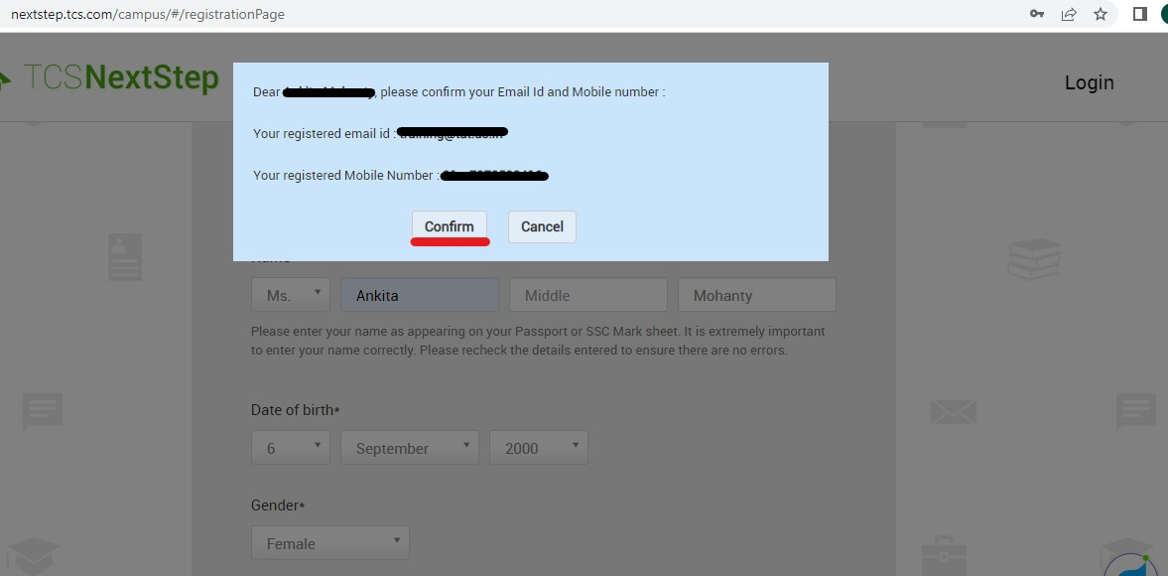

5. Note down your Reference ID for future login & click on Continue Button. Note: You need not worry if your reference no. starts with DT both CT/DT are applicable.
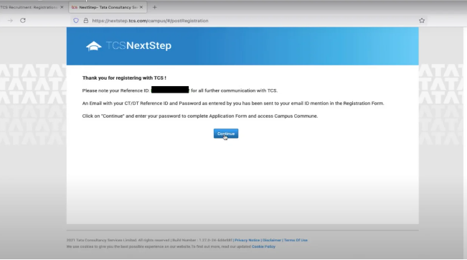

II. Filling of the Application Form
6. You will be directed to Home Page, click on the Application form to fill the details further.
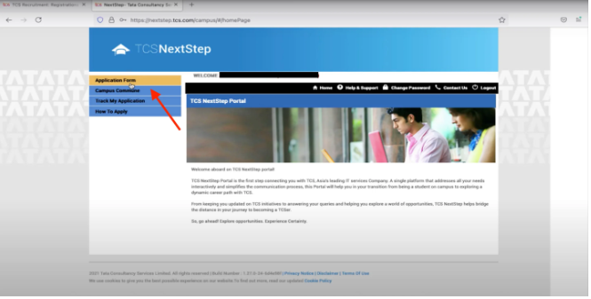
- Take time to read the instructions carefully & click on “Start Filling the Form”

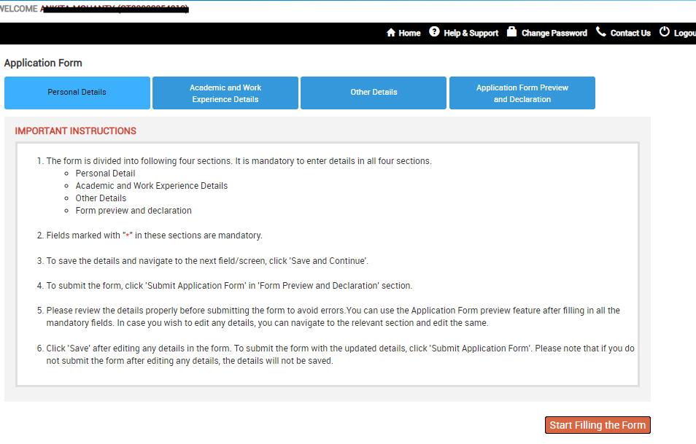
- First fill in the Personal Details Column. Here, you need to submit all the personal details correctly.
- Make sure to save and continue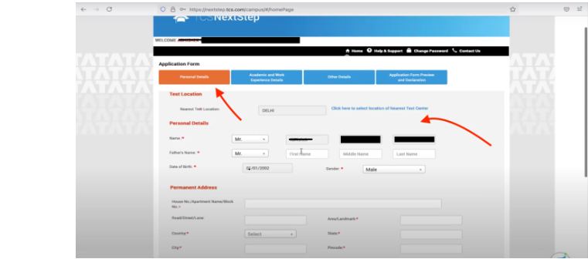
- Next read the academic instructions carefully before clicking on continue. Note: A green tick will be reflected over each tab after filling up of details successfully.
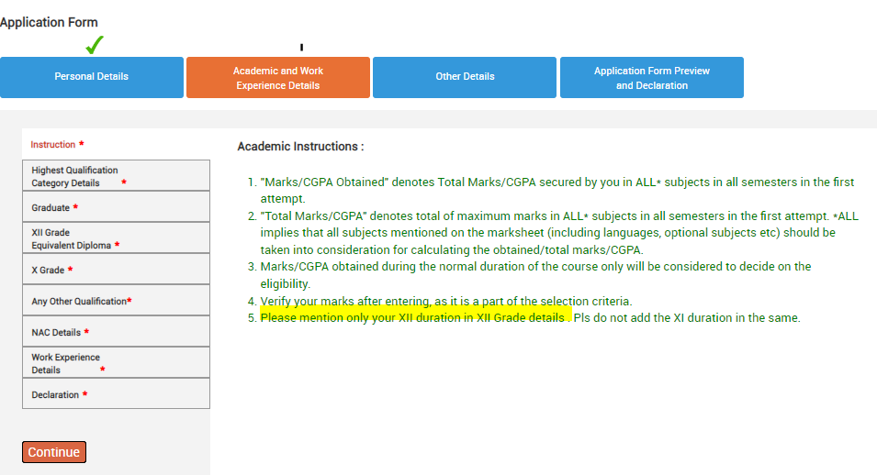

- After clicking on the Continue button the below page will appear. Note: For both TAT & TACT candidates college name will display as below from the dropdown
- Select your Highest Qualification & Year of Passing, then,
- Save and Continue
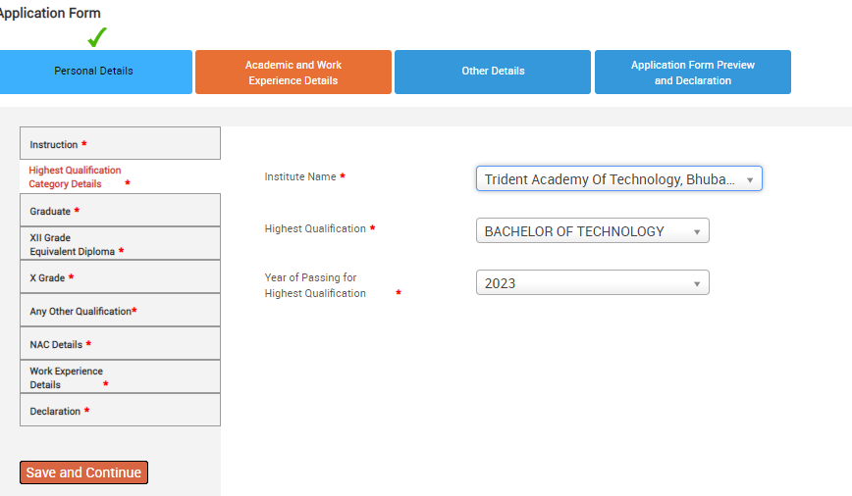
- Enter your Graduate details then “Save and Continue”
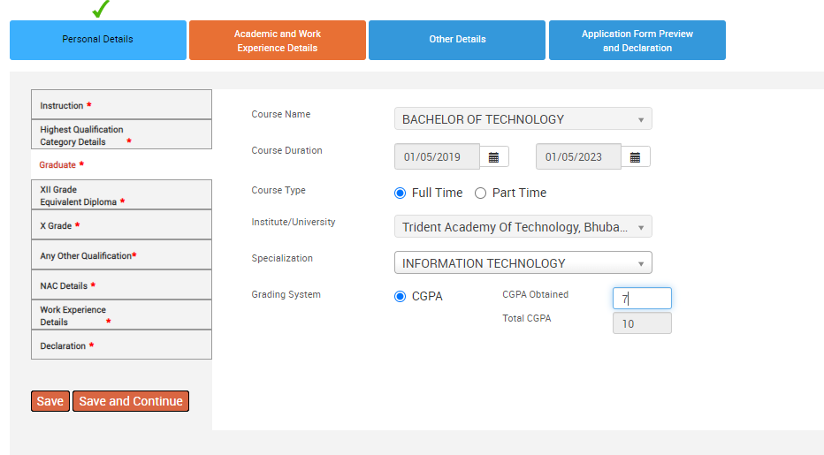
- Enter your XII Grade details carefully. NOTE: You only need to mention course duration for 12th grade and not 11th grade.
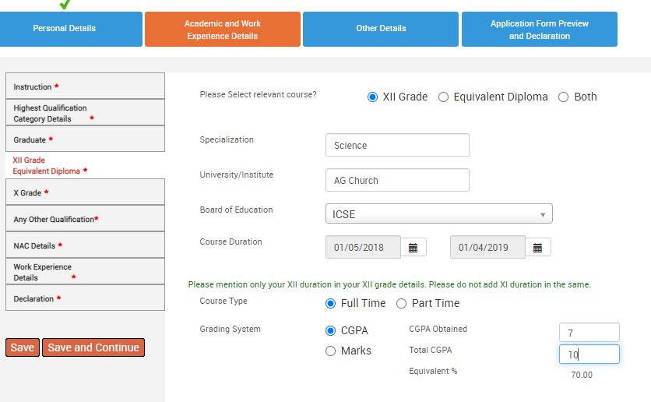
- After filling in your remaining mandatory details. You will land up on the Declaration page. Make sure to answer all the details correctly.
- Then click on “I agree”
- Save and Continue
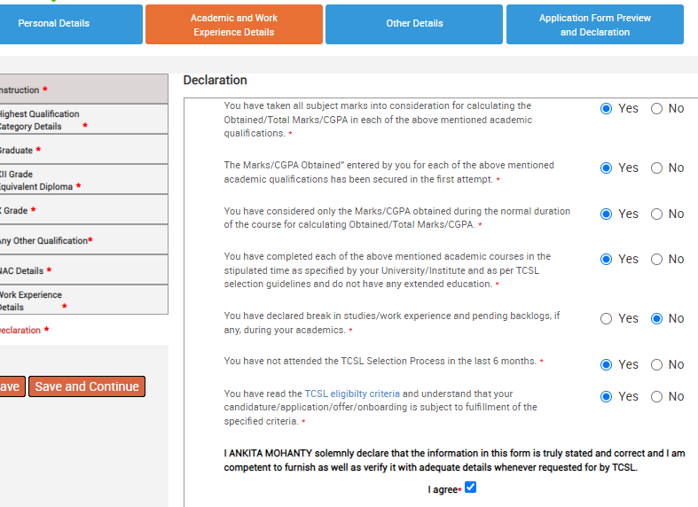
- Next section is the “Other Details”. After filling your details in “Nationality and Languages Known” save and continue to next
- “Achievements/Scholarship and Certifications” are not mandatory to fill. Add details ONLY if you have any achievements or certifications to show
- IMP: Upload your Photo & CV correctly. Read the instructs for correct dimension & file size
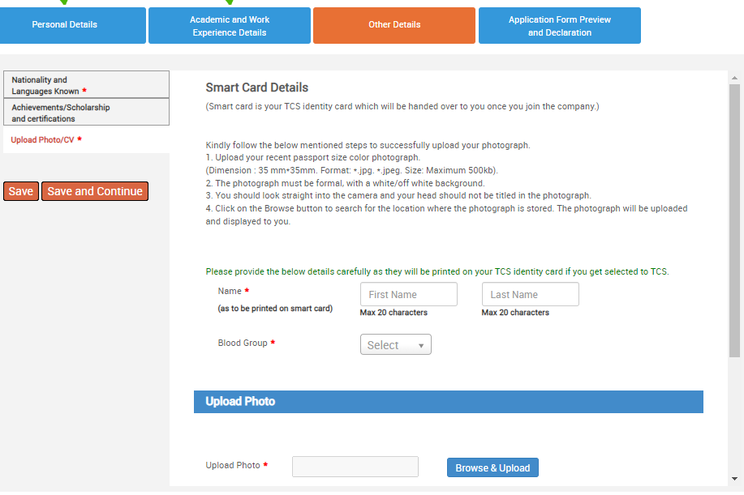
- Next tab is the “Application Form Preview and Declaration”. You need to answer the important details.
- Preview Application Form
- Click on I agree, enter Place & then click on “Submit Application Form”
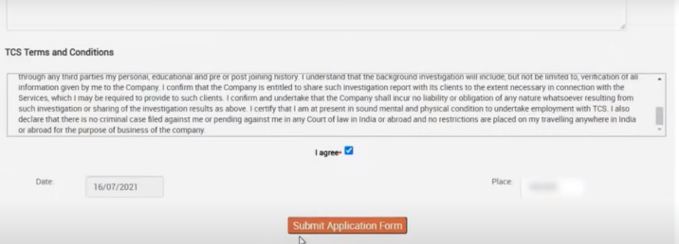

III. Track My Application for “Applied for Drive”

- IMP: A pop-up will appear asking “Apply for TCS Recruitment Drive?” You must click on Yes to proceed
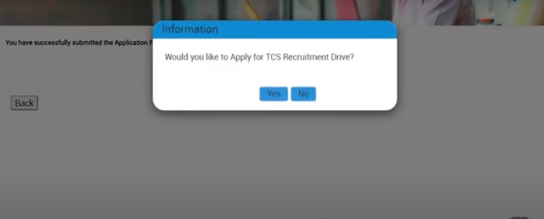
- You will be directed to the below given page where you need to choose the “Test Mode”
- Two drop-downs will appear i.e In-Centre & Remote. Carefully choose between the two as you can’t alter your choice later.
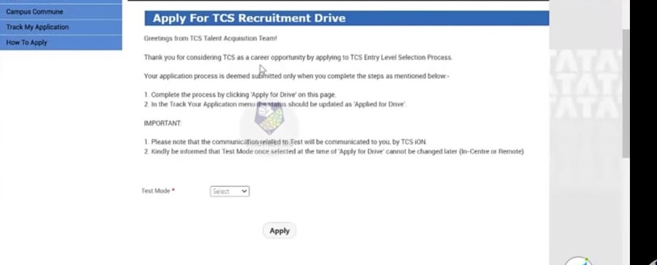

- Next go to Track My Application & look for the application status below for ensuring successful completion of the TCS NQT Ninja 2023 registration process. NOTE: Your status must reflect as Applied for Drive

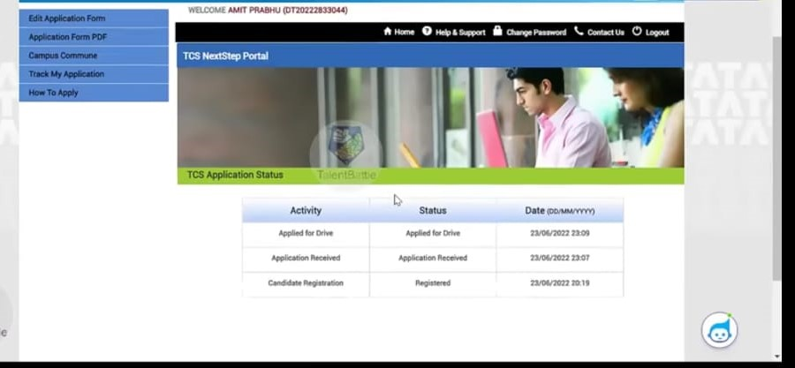

------------------------------------------END OF YOUR TCS REGISTRATION PROCESS---------------------------------

