

About Us:
IndiaMART is India's largest online B2B marketplace, connecting buyers with sellers. Over last 26 years, we have been continuously evolving our platform using sophisticated business-enablement technologies to make doing business easy. Our credo, 'Bada Aasaan Hai,' appropriately depicts our approach. With 86 million product offerings and 7.2 million responsive supplier base, we provide ease and convenience to our 154 million buyers. Our IPO was a thumping success in 2019, reaffirming the trust of our users and investors alike.

Headquartered in Noida, we have 3,800+ employees located across 36 offices in the country.

Why Join IndiaMART :

Our greatest assets are the IndiaMARTians. For our employee’s personal and professional development, we provide a variety of career advancement opportunities as well as learning and development activities.


They get the benefit of working with India's largest online B2B marketplace along with a fast-paced career progression. Potential employees can advance to the leadership roles within five years of their work tenure. We have more than 500 employees working with us who are testimony to this program.

The superheroes take advantage of our cutting-edge I-LEAP program, which allows employees to "Learn as they Work“. Our Superlative Incentive Programs, arguably among the best in business today, allow them to earn more as they do more.


IndiaMART InterMESH Ltd.
6th floor, Tower 2, Assotech Business Cresterra, Plot No.22, Sec 135,
Noida-201305, Uttar Pradesh, India.
Phone: +91 – 120 – 6777777

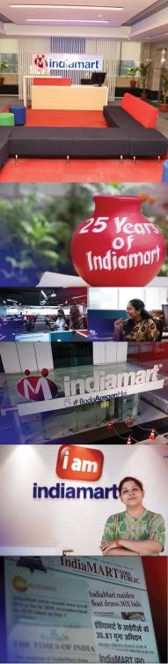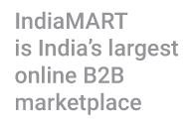

Key Success factors for an Individual:
- Passion and drive to excel
- Hunger to learn and grow
- Customer Orientation

What the Role offers:
- The position holder will be an individual contributor
- Build and manage productive, professional relationships with clients
- Ensure that clients are using and deriving benefits from IndiaMART
- Maximize revenue by retaining client and up-selling other services

Key Responsibilities:
- Achieve fortnightly, monthly client retention and revenue targets
- Service and monetize paying client
- Prompt resolution of client complaints
- Accurate mapping of products/services in client’s e-catalog
- Daily 4-5 in person meetings (F2F) with clients onsite
- Systematic follow-up with the clients to ensure time-bound closure
- Offer digital marketing solutions to help clients grow their business

Critical Skills of a Suitable Candidate:
- Application of sales techniques
- Active listening and understanding the business contexts of clients
- Good Verbal and written communication
- Ability to work independently

You Can Apply if you possess:
- Over 70% in 10th and 12th
- Will complete Masters Degree in Management in year 2023

Apply Now!

IndiaMART InterMESH Ltd.
6th floor, Tower 2, Assotech Business Cresterra, Plot No.22, Sec 135, Noida-201305, Uttar Pradesh, India.

